It’s Christmas Picnic Time

To everyone who have worked so hard to make all our activities, novena-masses and events for Senyor Santo Nino so blessed
by God and by your presence, we would like to celebrate.

A Good way to celebrate our working together is to have fun together.

This time we want to hold our Youth & Family Event in an open space where everyone, the “Young”, the “Not so Young” and the “Young Once” can really enjoy and have a very relaxing time in open air, with some cool breeze and watch the kids have fun.

Suggested Date Sunday November 30 at Cornwall Park from 1pm to 4-5pm.

We believe this would be a good time for all as everyone can get really busy as soon as December draws in?

Kindly keep this date open.

We need volunteers to get the day rolling with lots of surprises and fun. You don’t have to be an expert,
But you will have lots of humour and can create so much fun.

We’ll have lots of prizes on the run.

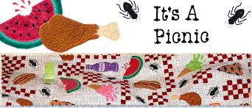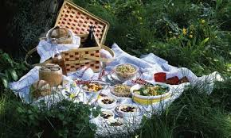

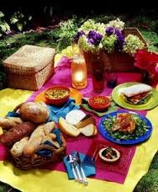
Lots of Fun, Food and Games

Relaxation for adults

God bless us all.

Tito Oscar and Tita Miriam
P.S. We will invite other groups who have always been supporting us.

